Infinite campus was updated to version 1705.3 over the weekend (Winter Break). One of the changes to the grade book is viewing the categories associated with a section. From Settings > Categories > change the Category List from All to a specific section.

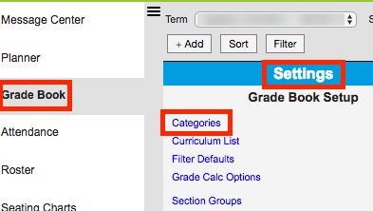

The “All” dropdown allows a teacher to see all the categories attached to all sections the teacher is attached to in Infinite Campus.
