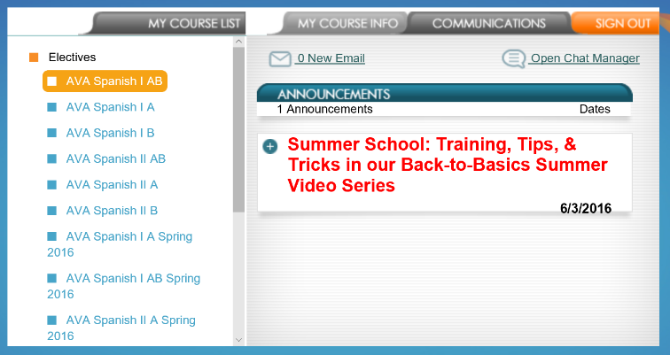

After logging into Genius via MyBackpack, click the course name.

This is the 1st screen you will see.

Click the name of your Spanish course.

accessing power speak and viewing progress

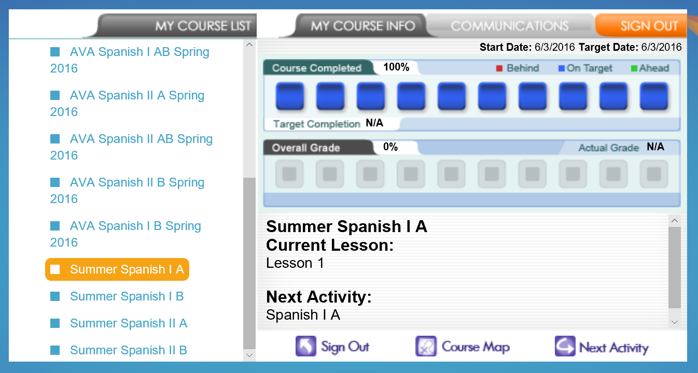

NOTE! This progress indicator is **NOT** accurate!

After clicking your Spanish course (highlighted gold), click “course map”.

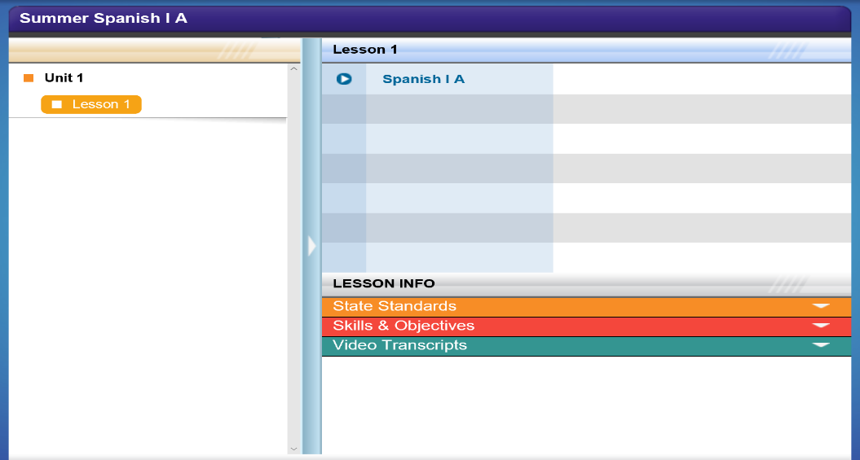

Then click the name of the course under “lesson 1”.

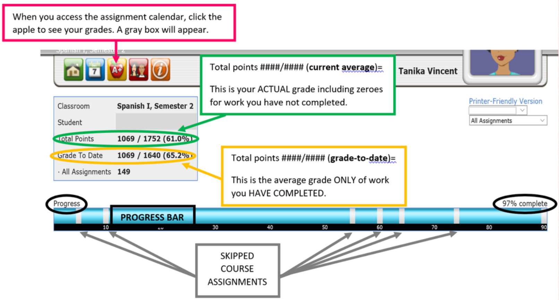

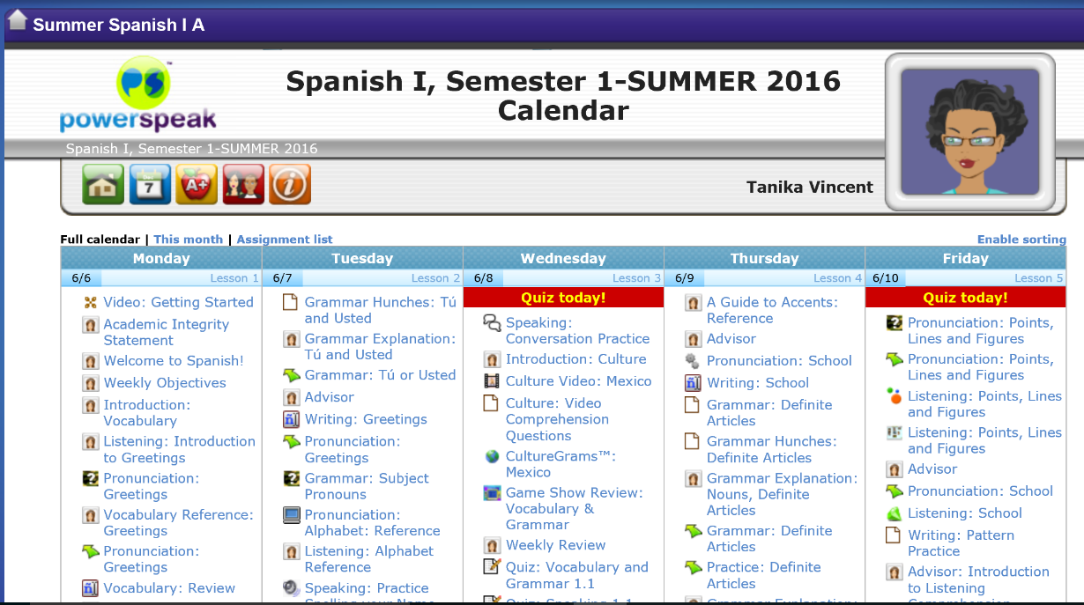

Your assignment calendar will appear.

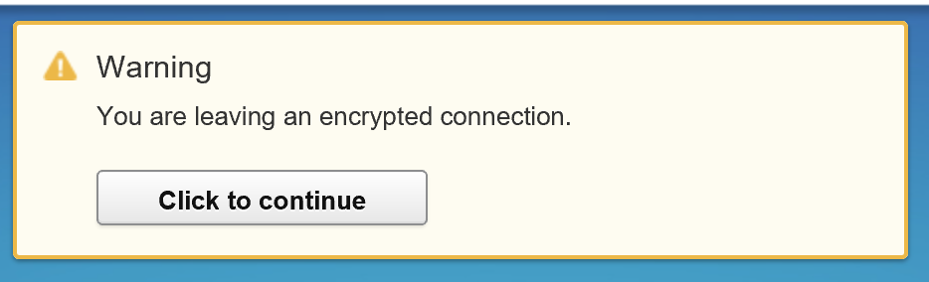

Click to continue.